

Dr. AMBEDKAR INSTITUTE OF TECHNOLOGY
(An Autonomous Institute, Affiliated to Visvesvaraya Technological University, Belagavi, Accredited by
NAAC, with “A” Grade)
Near Jnana Bharathi Campus, Bangalore – 560056

DEPARTMENT OF COMPUTER SCIENCE AND ENGINEERING
Master of Technology
in
Computer Science and Engineering

“BIG DATA ANALYTICS LABREPORT”

Submitted by

SRIPADA RAO H 1DA25SCS18

For the academic year 2026 - 2027
Under the Guidance of
Dr. Prabha R
Professor & HOP
Dept. of ISE, Dr. AIT

Visvesvaraya Technological University
Jnana Sangama, Belagavi, Karnataka 590018
2026 - 2027

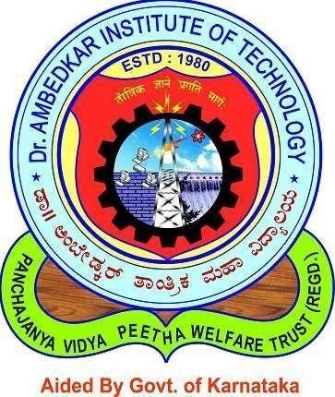
Dr. AMBEDKAR INSTITUTE OF TECHNOLOGY
(An Autonomous Institute, affiliated to VTU, Belagavi, Accredited by NAAC with ‘A’ Grade)
Near Jnana Bharathi Campus, Bengaluru – 560056

CERTIFICATE
“BDA Laboratory”
This is to certify that the submitted document in the partial fulfillment of the requirement of the M.Tec 2st semester BDA laboratory curriculum during the year 2025-26 is a result of Bonafede work carried out by-

H SRIPADA RAO 1DA25SCS18

Signature of the Incharge,

Dr. Prabha R
Professor & HOD Dr. AIT ISE
- Internal Examiner
- External Examiner

Dr. Prabha R
Head of Department, ISE Dr. AIT

